**Rice Data Analytics Bootcamp**

**Javier Olivero**

**Startups Analysis**



Table 1: State by Category. All Countries

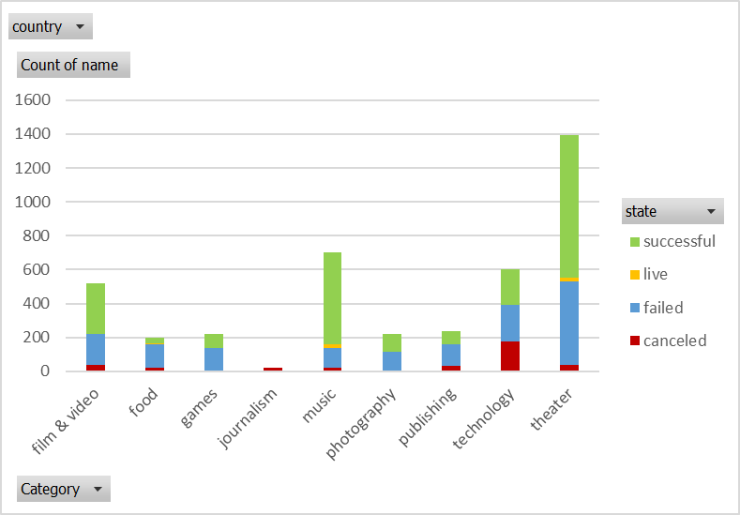

Graph 1: State by Category – All Countries



Table 2: State by Categories – All Countries

Graph 2: State by Sub-Categories – All Countries



Table 3: State by Month – All Countries, All Years

Graph 3: State by Month – All Countries, All Years



Table 4: Outcomes based on goals

Graph 4: Outcomes based on goals

**1.- Conclusions we can make about Kickstarter campaigns given the provided data:**

1.1.- “Theater”, “music”, and “film & video”, in that order, have the greatest number of successful initiatives.

1.2.- With regards to sub-categories, “plays” is an outlier, having by far the greatest number of initiatives and successful results.

1.3.- There is a significant increase of initiatives in the Summer months and the difference between the Successful initiatives and the failed ones is also the greatest in these periods, (There are more successes).

**2.- Some of the limitations of the dataset.**

One of the limitations of the data is that it has all the backers in the same pot without allowing to detect who has given the highest pledges. The data also calls success if the total pledge is higher than the goal, but we don’t have any insight on what initiatives are more profitable in order to plan on continuing those. Another problem that I see is that we have different currencies. This limits our possibility of comparing the different startups. (This could be eliminated if we also add another table with conversions and merge that table with the original and then if we calculate everything in a single currency).

**3.- Other possible tables or graphs**

3.1.- We can filter Table 3 to eliminate the outlier and to have a better insight of the other initiatives.

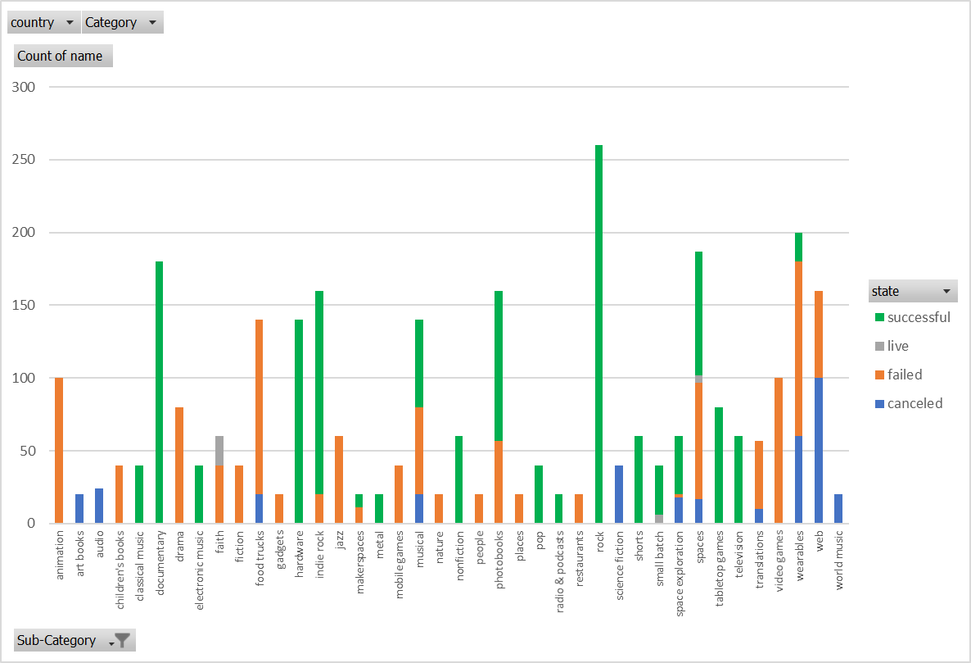

With this graph there is much more we can tell about the sub-categories. We see for example that all the animations failed, that rock is a very important sub-category and that all rock initiatives succeeded. The same can be told for documentaries and hardware, etc.

Another table that I would like to see is the numbers by countries:



Now we can see that most of the initiatives are carried out in the USA, followed by Great Britain and Canada. That way, we can repeat graphs 1, 2, 3, and 4 but filtering for each of these countries and to get more insight.